2018 WITAN FRENCH MARKET PROGRAM ADVERTISING

In 2017, WITAN (Women In Touch With Akron’s Needs) raised $65,000 through two fundraisers: the WITAN French Market Juried Arts and Crafts Show and the Imagine Ball. This money was directly allocated to community non-profits through grants. One way we raise funds is through selling ads in our French Market Program.

The 2018 WITAN French Market Program is distributed to approximately 2,500 individuals who visit the juried art show each year. In addition, advertisers will be listed on the WITAN website www.witaninfo.org for all of 2018.

Advantages to purchasing an ad in this program include:

- WITAN’s French Market is an Akron tradition – 2018 will be the 41st year and has a significant following in Northeast Ohio.

- The majority of the shoppers come from all along the I-77 and I-71 corridors from Canton up to Cleveland and the surrounding suburbs.

- Our shoppers range in demographics from young millennial to seniors, and professionals to retirees.

- Vendors come from as far away as Mid Pennsylvania, Northern Kentucky, Western West Virginia, Eastern Indiana, and Southern Michigan.

- All advertisers in the program will be listed on the WITAN website under the French Market tab with links to your business for the remainder of the year.

- Ad rates are competitive for the advertising your business will receive – you will receive significant exposure to potential customers for a very minimal investment.

- Program design will be done by professional graphic design and printing firm for high quality results.

- WITAN a 501(c)(3) non-profit organization and your purchased ad may be tax deductible (check with your tax professional).

- Purchasing an ad in our program sends money directly back to the greater Akron/Summit County community in the form of Community Service Grants we award to non-profits each year in May.

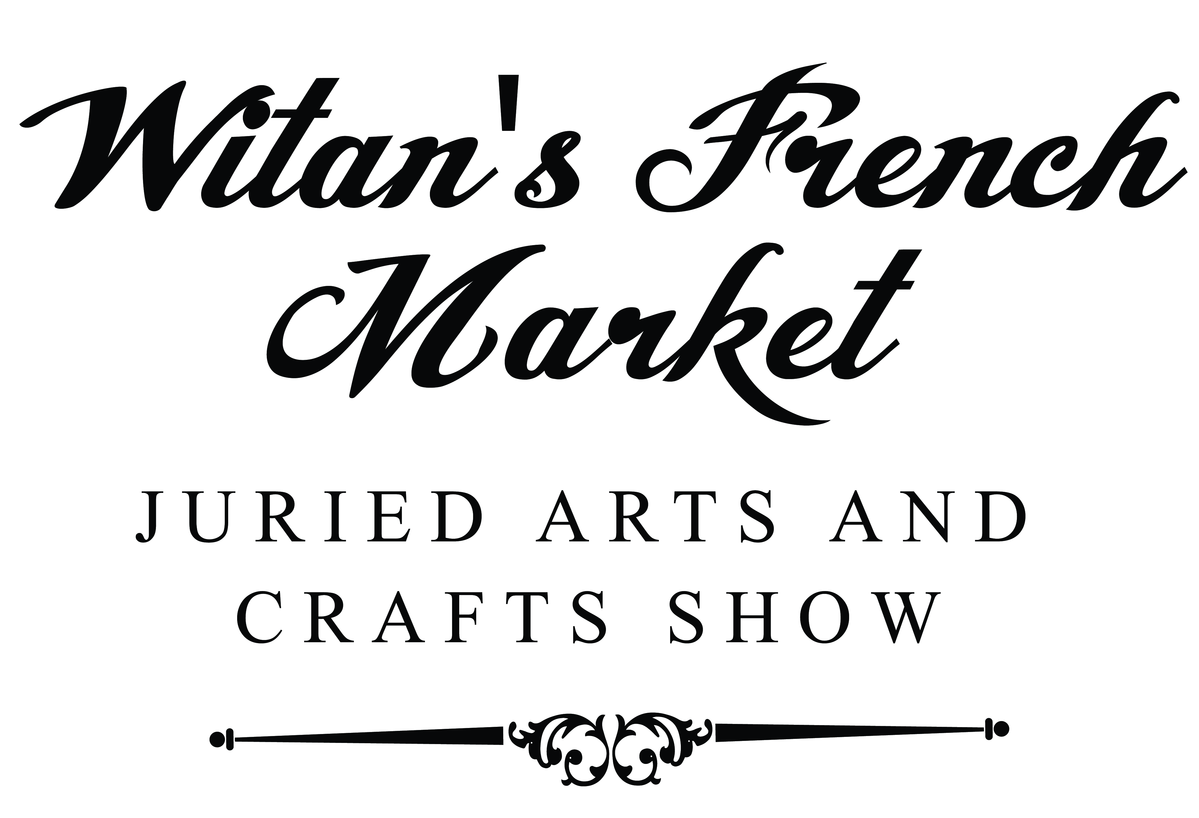

WITAN FRENCH MARKET 2018 PROGRAM ADVERTISING ORDER

We can work from actual business cards (clean and ready for print) or PDF of business card. All other ad artwork must be submitted as a PDF with 300dpi. The program will be printed black and white only. We can provide minimum assistance with resizing if your PDF does not exactly fit your purchased space (no additional cost). (Note: We will not be able to create your ads or complete layouts for you but can put you in contact with the printer for design assistance at your cost.)

All ad artwork and business cards must be received by midnight, February 16, 2018. All ad/artwork that is not an actual business card must be submitted to us at: witanfrmktbook@gmail.com. Please attach your business card to this form. Payment for these ads is due by the same date above. Payment must accompany this form – cash or check. Please email any questions to the above email address or call 330.697.3487.

Type Page Ad  (Please Attachment for Layouts) | Dimensions | Cost | How Many | Total Cost
Full Page Inside Cover - Front | 4.5” x 7.5” | $125.00
Full Page Inside Cover - Back | 4.5” 7.5” | $125.00 | +++SOLD+++ | +++SOLD+++
Full Page | 4.5” x 7.5” | $100.00
Half Page Vertical Inside Cover - Front | 2.25” x 7.5” | $100.00
Half Page, Vertical | 2.25” x 7.5” | $75.00
Half Page Horizontal Inside Cover – Front | 4.5” x 3.5” | $100.00
Half Page, Horizontal | 4.5” x 3.5” | $75.00
Quarter Page | 2.25” x 3.5 | $40.00
Business Card | 3.25” x 2” | $20.00

Name: ________________________________________________________________________________________

Business Name: _________________________________________________________________________________

Address: _______________________________________________________________________________________

City: ________________________________________ State: ________________ Zip: ________________________

Phone: Business: _________________________________ Mobile: ________________________________________

Email address: __________________________________________________________________________________

Total Number ads: _______________________Total Amount Due: ________________________________________

Total Paid: _______________________ Cash: _________________ Check: _____________________

Received by: __________________________________________________________________________________

PDF artwork or business card submitted? Yes ______ No ________
